System Segmentation Specification
for
Smart House System

Table of Contents
1 Scope 6
1.1 Identification 6
1.2 System Overview 6
1.3 Document Overview 6
2 References 8
2.1 General References 8
2.2 Specific References 8
2.3 Acronyms and Abbreviations 8
3 Requirements 9
3.1 Required states and modes 9
3.1.1 System States 9
3.1.2 System Modes 11
3.2 System external interface requirements 12
3.2.1 (Project-unique identifier or interface) 14
3.3 System capability requirements 19
3.3.1 System capability 19
3.4 System internal interface requirements 27
3.4.1 System State Diagram 28
3.4.2 Brain 28
3.4.3 Environmental 28
3.4.4 Inventory 29
3.4.5 Quality of Life 29
3.4.6 Security 33
3.4.7 Detector Data 33
3.4.8 Utility Manager 33
3.5 System internal data requirements 33
3.6 Adaptation requirements 34
3.7 Safety requirements 36
3.8 System environment requirement 38
3.9 Computer resource requirements 38
3.9.1 Software Environment 39
3.9.2 Hardware Environment 39
3.9.3 Natural Environment 39
3.9.4 Computer software requirements 40
3.10 System quality factors 40
3.10.2 Computer Hardware Resources Utilization 42
3.10.3 Computer communications requirements 42
3.11 System Quality Factors 43
3.12 Design and Construction Constraints 44
3.13 Personal-Related Requirements 45
3.14 Training-Related Requirements 46
3.15 Logistics-related Requirements 47
3.16 Other requirements 47
3.17 Packaging Requirements 48
3.18 Precedence and Criticality of Requirements 49
4 Qualification Provisions 50
5 Requirements traceability 51
6 Notes 52

List of Tables
Table 1: Acronyms and Abbreviations 8

List of Figures
Figure 1: DFD-O 29
Figure 2: DFD-3.4.5 31
Figure 3: DFD-3.4.5.2 32
Figure 4: STD-3.4.5.2.1 33
Figure 5: DFD-3.4.5.2.2 34
Figure 6: STD-3.4.5.2.2.1 35
Figure 7: DFD-3.4.5.2.3 37
Figure 8: STD-3.4.5.2.3.1 38
Figure 9: DFD-3.4.5.2.4 40
Figure 10: STD-3.4.5.2.4.1 41
Figure 11: STD-3.4.5.2.5 43
Figure 12: STD-3.4.5.2.5.1 44
Figure 13: DFD-3.4.5.3 45
Figure 14: DFD-3.4.5.3.2 46
Figure 15: STD-3.4.5.3.2.1 46
Figure 16: DFD-3.4.5.3.3 47
Figure 17: STD-3.4.5.3.3.1 48
Figure 18: DFD-3.4.5.3.4 49
Figure 19: STD-3.4.5.3.4.1 50
Figure 20: DFD-3.4.5.4.1 51
Figure 21: DFD-3.4.5.4.2.1 52
Figure 22: STD-3.4.5.4.2.2 53
Figure 23: STD-3.4.5.4.2.3 54
Figure 24: STD-3.4.5.4.3 54
Figure 25: STD-3.4.5.4.4 55
Figure 26: DFD-3.4.5.4.5 56

List of Requirements
Requirement 3.1.1.1.1 : Boot-Up State 9
Requirement 3.1.1.2.1: Shutdown State 9
Requirement 3.1.1.3.1: Occupied-State 10
Requirement 3.1.1.4.1 : Unoccupied-State 10
Requirement 3.1.2.1.1 : Normal Mode 11
Requirement 3.1.2.2.1 : Emergency Mode 11
Requirement 3.1.2.3.1 : Training mode 12
Requirement 3.1.2.4.1 Maintenance mode 12
Requirement 3.2.1.1 : Alarm Siren 14
Requirement 3.2.1.2 : Light Controllers 14
Requirement 3.2.1.3 : Outdoor Light Sensor 15
Requirement 3.2.1.4 : Indoor Temperature Sensor 15
Requirement 3.2.1.5 : Outdoor Temperature Sensor 16
Requirement 3.2.1.6 Voice commands 16
Requirement 3.2.1.7 : Human Sensor Interface 17
Requirement 3.2.1.8 : Music System Interface 18
Requirement 3.2.1.9 : Image Display Interface 19
Requirement 3.3.1.1 :Syntax 19
Requirement 3.3.1.2 Loudness 20
Requirement 3.3.1.3 Softness 20
Requirement 3.3.1.4 Languages 21
Requirement 3.3.1.6 : User Data Storage 21
Requirement 3.3.1.7 : Contact/Personal Information Profile Settings 22
Requirement 3.3.1.8 : Privilege Profile Settings 23
Requirement 3.3.1.9 : Music Profile Settings 24
Requirement 3.3.1.10 : Art Profile Settings 25
Requirement 3.3.1.11 : Voice Pattern Storage and Recognition 26
Requirement 3.5.1 : Vacation Schedule Database 27
Requirement 3.5.2 : Work Schedule Database 28
Requirement 3.6.1 : Day Light Savings Time 28
Requirement 3.6.2 : Light Controllers 29
Requirement 3.6.3 : Age Groups 29
Requirement 3.6.4 : Background noise 29
Requirement 3.7.1 : Password Encryption 30
Requirement 3.7.2 : UL 30
Requirement 3.7.3 : Emergency requests 31
Requirement 3.8.1 : Intruder detection 31
Requirement 3.8.2 : Environment Temperature 32
Requirement 3.9.1.1 : Software environment 32
Requirement 3.9.2.1 : Hardware environment 33
Requirement 3.10.1 : Voice processing units 34
Requirement 3.10.2 : Voice interpretation units 34
Requirement 3.10.1.1.1 : Storage Requirements 35
Requirement 3.10.1.1.2 : Memory Requirements 35
Requirement 3.10.2.1 : Internal memory 35
Requirement 3.10.3.1 : Training software 36
Requirement 3.10.3.2 : Voice data rates 36
Requirement 3.11.1 : Re-usability 37
Requirement 3.12.1 : Material constraints 37
Requirement 3.12.2 : Profile/Settings Storage 38
Requirement 3.12.3 : Programming Language 38
Requirement 3.13.1 : Online support chat 38
Requirement 3.13.2 : Manual Specification 39
Requirement 3.14.1 : Training 39
Requirement 3.15.1 : Software Updates 40
Requirement 3.15.2: Microphone maintenance 40
Requirement 3.16.1 : Digital user manual 41
Requirement 3.17.1 : Voice command package 41
Requirement 3.17.2: Packaging Material 42

Scope
This document provides the System Segmentation Specification for modification of the Smart House System. Thus, the system described herein shall be known as the Smart House.

Identification
The Smart House system described herein shall be identified as version 2.0.0. This system shall serve as a replacement for the current system, which is identified as 1.2.9.

System Overview
The Smart House system shall serve as a house automation system with user preference and scheduling procedures. This system is designed to make everyday living simpler and more user defined. The quality of life part is one of the four major components of the system and will include a user profiling section, a voice recognition section, a scheduling section and a miscellaneous section.

Document Overview
This document provides the system subsystem specification (SSS) for the Smart House System. This document format is based upon the format as provided in Reference [OCD]. The system and subsystem performance specification and acceptance criteria are documented following the guidelines of ISO-12207 [1] and MIL-STD-498 [2] (from which ISO-12207 originated). This section provides an overview of the system and this document. Section 2 provides a list of general and application-specific reference documents as well as an acronym list. Section 3 provides the detailed requirements for the system. Section 4 general notes as applicable. Detailed information is provided in appendices as is applicable.
This document follows the format as specified in reference 3. A change in format has been made that allows for the system interfaces to be specified before the system capabilities. The net result of this change is that system capabilities are presented in section 3.3 instead of 3.2 and external system interfaces are described in section 3.2 instead of section 3.3. A second change is that the qualification provisions are listed with each requirement rather in a matrix in Section 4.
The requirements are listed by sub-system. The fully qualified requirement number includes the sub-section in which it is contained. The requirement numbers are tied to the sub-system level thus they are numbered from 1 to N for each sub-section of the requirements section. This is done to allow for additions within a sub-system without affecting other sub-systems. Once a requirement has been active, it cannot be deleted, only its status may be changed to deleted to preserve numbering.

Each requirement is defined in the following format:

Requirement Sub.Section-#: Requirement Name or Title
Synopsis: | Generalized statement of this requirement. This is a simplification of the requirement. The requirement details (and thus the testable items) are provided in the specifics section.
Specifics: | Specialized information regarding this requirement for the specified application.  - Parameters that are To Be Determined are listed as __TBD__.  - List all “sub-requirements” in lettered list so that their numbers are Rqt 1.2.3.4-1.A, Rqt 1.2.3.4-1.B and so forth
Acceptance: | The criteria that shall be used to determine acceptance of this component. These criteria will be coalesced into an overall ATP to be executed upon delivery and installation of the system. Acceptance of a requirement will be in the form of one of the following methods:  - Inspection – the requirement will be accepted based upon results of the inspection and review of the system or documentation  - Demonstration – the requirement will be accepted based upon operational demonstration of the capability with no prejudice towards the performance of the capability.  - Testing – the requirement will be accepted by running the system to collect data and the resultant analysis of the data to verify the performance.  - Analysis – The processing of accumulated data obtained from other qualification methods. Examples are reduction, interpolation, or extrapolation of test results.  - Special qualification methods. Any special qualification methods for the system, such as special tools, techniques, procedures, facilities, acceptance limits, use of standard samples, preproduction or periodic production samples, pilot models, or pilot lots.
Status: | Active or In-Active. Active requirements are to be met by the system for the specified use and shall be subject to the acceptance criteria. In-Active requirements shall not be subject to the acceptance criteria.  In-Active requirements are shown in gray regions.
Notes: | These are general notices and issues regarding the component. Notes shall not be considered part of the formal requirements.

References
This documentation references to the OCD of the Smart House System

General References
[SSS_DID] DI-IPSC-81431 Data Item Description for System Subsystem Specification (SSS), MIL-STD-498, 05 Dec 1994.

Specific References
[Federal Standard 1037C] Telecommunications: Glossary of Telecommunication Terms, http://www.its.bldrdoc.gov/fs-1037/fs-1037c.htm, August 7, 1996

Acronyms and Abbreviations

Table 1: Acronyms and Abbreviations
DID | Data Item Description
OCD | Operational Concept Description
UID | Unique Identifier (for user's profiles)

Requirements

Required states and modes
This section lists the states and modes that are provided by the system. States are high-level operation levels such as “boot-up”, “running”, “shutdown”, and maybe “off”. Sub-states list sub-levels for each state as applicable. For example, the “boot-up” state may have sub-states like “power-up”, “reading boot media”, etc. Modes and sub-modes are traditional operational modes within a state. For example, the “running” state may have modes such as “normal”, “maintenance”, “training”, etc.

System States

Boot Up State
Requirement 3.1.1.1.1 : Boot-Up State
Synopsis: | The system shall provide a boot-up state in which the system prepares for operation.
Specifics: | - The system shall provide a boot-up state in which the system prepares for operation.
Acceptance: | This requirement shall be verified by inspection.
Status: | Active
Notes: | N/A
Source | All of us

Shutdown state
Requirement 3.1.1.2.1: Shutdown State
Synopsis: | The system shall provide a shutdown state in which the system ceases operations.
Specifics: | - The system shall provide a shutdown state in which the system ceases operations.
Acceptance: | This requirement shall be verified by inspection.
Status: | Active
Notes: | N/A
Source | All of us

Occupied-State

Requirement 3.1.1.3.1: Occupied-State
Synopsis: | The system shall differentiate between occupied and unoccupied to detect intruders.
Specifics: | - The system shall provide a occupied state to identify authorized users.
Acceptance: | This requirement shall be verified by inspection.
Status: | Active
Notes: | N/A
Source: | Andre Zierfuss

Unoccupied State

Requirement 3.1.1.4.1 : Unoccupied-State
Synopsis: | The system shall differentiate between occupied and unoccupied to detect intruders.
Specifics: | - The system shall provide a unoccupied state to identify unauthorized users.
Acceptance: | This requirement shall be verified by inspection.
Status: | Active
Notes: | N/A
Source: | Andre Zierfuss

System Modes

Normal Mode
Requirement 3.1.2.1.1 : Normal Mode
Synopsis: | The system shall provide a normal mode in which the system operates normally.
Specifics: | - The system shall provide a normal mode in which the system operates normally.  - The normal mode shall only exist in the occupying state.
Acceptance: | This requirement shall be verified by inspection.
Status: | Active
Notes: | N/A
Source | All of us

Emergency Mode
Requirement 3.1.2.2.1 : Emergency Mode
Synopsis: | The system shall provide an emergency mode which enables emergency requests priority processing.
Specifics: | - The system shall provide an emergency mode enabling priorities for emergency relevant requests.  - The emergency mode shall only exist in the occupying state.
Acceptance: | This requirement shall be verified by inspection.
Status: | Active
Notes: | N/A
Source | All of us

Training Mode
Requirement 3.1.2.3.1 : Training mode
Synopsis: | The system shall provide a training mode that allows for adaptation of the user’s voice characteristics.
Specifics: | - The system shall provide a training mode that allows for adaptation of the user’s voice characteristics.  - The B. Training mode shall only exist in the occupying state.
Acceptance: | This requirement shall be verified by special qualification methods.
Status: | Active
Notes: | N/A
Source: | All of us

Maintenance Mode
Requirement 3.1.2.4.1 Maintenance mode
Synopsis: | The system shall provide a maintenance mode to guarantee an optimum performance of the microphones over time.
Specifics: | - The system shall provide a maintenance mode to guarantee an optimum performance of the microphones over time.
Acceptance: | This requirement shall be verified by special qualification methods.
Status: | Active
Notes: | N/A
Source: | All of us

System external interface requirements

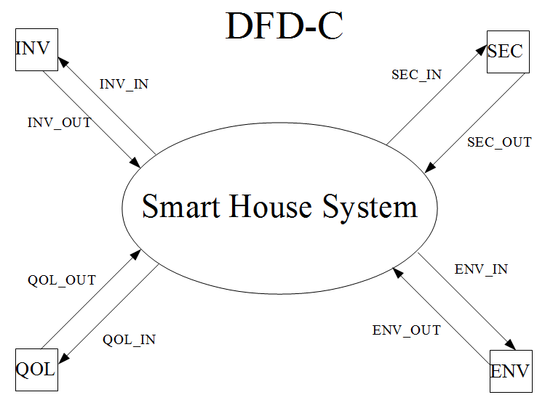

(Project-unique identifier or interface)
Requirement 3.2.1.1 : Alarm Siren
Synopsis: | The system shall provide an alarm to notify the user when they have scheduled tasks or when to wake up.
Specifics: | - The system shall provide an emergency mode in which the system allows emergency vehicles priority passage.
Acceptance: | This requirement shall be verified by inspection.
Status: | Active
Notes: | N/A
Source: | Andrew Poirier

Requirement 3.2.1.2 : Light Controllers
Synopsis: | The system shall provide electronic light controllers to turn the lights on or off.
Specifics: | - The system shall have electronic light controllers to control the electricity to the lighting devices when requested by the system.
Acceptance: | This requirement shall be verified by inspection.
Status: | Active
Notes: | This is used to turn the lights on or off.
Source: | Andrew Poirier

Requirement 3.2.1.3 : Outdoor Light Sensor
Synopsis: | The system shall provide an outdoor light sensor to determine if the sun is our or if it is night time.
Specifics: | A. The system shall provide an outdoor light sensor to determine the amount of light that is outside.
Acceptance: | This requirement shall be verified by inspection.
Status: | Active
Notes: | This will be used to let the system know when to turn the “night time mode” lights on or off.
Source: | Andrew Poirier

Requirement 3.2.1.4 : Indoor Temperature Sensor
Synopsis: | The system shall provide an indoor temperature sensor to determine the temperature of the house.
Specifics: | A. The system will have temperature sensors in each room to zone the house properly based on what user is in each room
Acceptance: | This requirement shall be verified by inspection.
Status: | Active
Notes: | To zone each room based on what user is in it.
Source: | Andrew Poirier

Requirement 3.2.1.5 : Outdoor Temperature Sensor
Synopsis: | The system shall have access to an outdoor temperature sensor to determine maximum efficiency when scheduling the HVAC schedule.
Specifics: | A. The system shall provide a shutdown state in which the system ceases operations.
Acceptance: | This requirement shall be verified by inspection.
Status: | Active
Notes: | N/A
Source: | Andrew Poirier

Requirement 3.2.1.6 Voice commands
Synopsis: | The system shall provide a set of applicable commands.
Specifics: | - The system’s command types shall be provided in a basic command list  - The system shall be able to bind personal expressions to existing actions listed in the command list  - The system shall ignore the content after a keyword if the time in between exceeds 3 seconds  - The system shall only accept voice commands in the occupying state.
Acceptance: | This requirement shall be verified by testing.
Status: | Active
Notes: | N/A
Source: | Andre Zierfuss
Requirement 3.2.1.7 : Human Sensor Interface
Synopsis: | The system shall have the ability to interface with a sensor to obtain the UID for all occupants of a given room and of the smart house.
Specifics: | - The system shall maintain a listing of the active (inside the house) UIDs tied to the room that the user is currently occupying.  - The system shall be notified within one second upon UID location changes or exits (leaving the reach of the sensors/system).
Acceptance: | This requirement shall be verified by inspection, testing, and demonstration.
Status: | Active
Notes: | N/A
Source: | Tyler Kopf

Requirement 3.2.1.8 : Music System Interface
Synopsis: | The system shall have the ability to interface with a music player/system and speakers.
Specifics: | - The music player/system shall be capable of selecting music based on genre, artist, album, and track and shall be capable of receiving commands from the Smart House System to select the music by those qualifiers.  - The music player/system shall maintain its own database of music.  - The music player/system shall be external to and independent developed from the Smart House System.  - The system shall interface with the music player to set volume and output the sound to speakers typically used by the voice response system located in each room.
Acceptance: | This requirement shall be verified by inspection, testing, and demonstration.
Status: | Active
Notes: | N/A
Source: | Tyler Kopf
Requirement 3.2.1.9 : Image Display Interface
Synopsis: | The system shall have the ability to interface with a display screen to display a user's preferred artwork. The idea is for the system to optionally support LED/LCD style “paintings” hanging on the walls in the Smart House.
Specifics: | - The system shall be capable of storing artwork images.  - The system shall be capable of interfacing with displays supporting 1.6 aspect ratios to send visual data.  - The system shall support both portrait and landscape mode for 1.6 aspect ratios.  - The system shall be capable of selecting appropriate artwork from storage according to UID and sending the stored artwork to the display.  - The system shall have the ability to interface with the display in order to turn it off when a room is vacant.
Acceptance: | This requirement shall be verified by inspection, testing, and demonstration.
Status: | Active
Notes: | N/A
Source: | Tyler Kopf

System capability requirements

System capability
Requirement 3.3.1.1 :Syntax
Synopsis: | The system shall provide a pre-defined syntax to the user for communication.
Specifics: | - The system’s syntax for a voice command shall have two components KEYWORD + CONTENT.
Acceptance: | This requirement shall be verified by demonstration.
Status: | Active
Notes: | N/A
Source: | Andre Zierfuss

Requirement 3.3.1.2 Loudness
Synopsis: | The system shall detect moderate voice level and emergency voice level of the user.
Specifics: | - The system’s general detection level s range from 0 dB to 130 dB.  - The system shall identify moderate communication for voice ranges from 20 dB to 80 dB.  - The system shall identify emergency communication for voice ranges from 80 dB to 130 dB.
Acceptance: | This requirement shall be verified by demonstration.
Status: | Active
Notes: | - 0 dB to 130 dB. (from the threshold of excellent youthful hearing to the threshold of pain and immediate ear damage)  - 20 dB to 80 dB. ( from to awaken a sleeping person, normal office noise, quiet stream, conversational speech to car horn at 5 meters)  - 80 dB to 130 dB. (from noisy office, electric shaver, alarm clock, police whistle to the threshold of pain and immediate ear damage)
Source: | Andre Zierfuss

Requirement 3.3.1.3 Softness
Synopsis: | The system shall provide a minimum voice level for command acceptance.
Specifics: | - The system’s minimum voice level accepted for voice commands is 20 dB.
Acceptance: | This requirement shall be verified by demonstration.
Status: | Active
Notes: | 20 dB (whisper, empty theater, ticking of watch)
Source: | Andre Zierfuss
Requirement 3.3.1.4 Languages
Synopsis: | The system shall accept English, German, French, and Spanish for voice commands.
Specifics: | - The system shall accept English, German, French, and Spanish for voice commands.
Acceptance: | This requirement shall be verified by testing.
Status: | Active
Notes: | N/A
Source: | Andre Zierfuss

Requirement 3.3.1.6 : User Data Storage
Synopsis: | The system shall have have the ability to store personalized data for each user of the system.
Specifics: | - The system shall provide unique identifiers (UIDs) tied to profile storage for each user.  - The system shall provide a default profile for new or unrecognized users that shall also be tied to a single unique identifier (UID).  - The system shall support no less than 256 major profile settings  - The system shall allow voice access to change all profile settings for a UID by the user tied to that UID within reason unless otherwise specified below.  - The system shall allow voice access to change all profile settings for any UID with lower privileges less than a user issuing the voice command.
Acceptance: | This requirement shall be verified by testing.
Status: | Active
Notes: | N/A
Source: | Tyler Kopf
Requirement 3.3.1.7 : Contact/Personal Information Profile Settings
Synopsis: | The system shall have the ability to store personal information on each user as described below.
Specifics: | - The system shall tie the contact/personal information to the UID for each user and store the data in the profile settings.  - The system shall have the capability to store a user's name, age, birth date, address, phone numbers, and photograph.  - The system shall store an associated room (if one exists) with a UID to indicate that the room is “theirs” and that their preferences have precedence within said room.  - The system shall have the capability to store a user's contacts with the associated data including name, age, birth date, address, phone numbers, and photograph.
Acceptance: | This requirement shall be verified by testing.
Status: | Active
Notes: | N/A
Source: | Tyler Kopf
Requirement 3.3.1.8 : Privilege Profile Settings
Synopsis: | The system shall have the ability to store privilege settings for each UID.
Specifics: | - The system shall store data on user privileges for each UID.  - The system shall provide a default UID privilege level.  - The system shall, at all times after set-up, have a UID with the highest level privileges.  - The system shall allow only users to increase the privilege level of another UID only up to one level below the initial users privilege level.  - The system shall make an exception to C. in the event that the user initiating the privilege change has the highest level privileges (owner).  - Where preferences conflict, unless otherwise stated, the UID with the highest privilege level takes precedence.
Acceptance: | This requirement shall be verified by testing.
Status: | Active
Notes: | N/A
Source: | Tyler Kopf
Requirement 3.3.1.9 : Music Profile Settings
Synopsis: | The system shall have the ability to store music preferences for each user.
Specifics: | - The system shall tie the music preferences to the UID for each user and store the data in the profile settings.  - The system shall support music preferences by genre, artist, albums, and tracks.  - The system shall be capable of setting volume levels on the music.  - The system shall maintain a preferred volume setting for the music.  - If the house is vacant all music will be put on pause. Upon re-entry, the music will begin to play again with the volume at a reasonable level (50 db).
Acceptance: | This requirement shall be verified by testing.
Status: | Active
Notes: | N/A
Source: | Tyler Kopf
Requirement 3.3.1.10 : Art Profile Settings
Synopsis: | The system shall have the ability to store art preferences for each user.
Specifics: | - The system shall tie the art preferences to the UID for each user and store the data in the profile settings.  - The system shall support art preferences by artist and artwork.  - The system shall store only artwork data that is two dimensional in nature (paintings, frescoes, watercolors, etc.)  - When no artwork is found associated with a UID the system shall display the artwork tied to the owner's UID.  - The system shall not attempt to display anything when a room is vacant.
Acceptance: | This requirement shall be verified by testing.
Status: | Active
Notes: | N/A
Source: | Tyler Kopf
Requirement 3.3.1.11 : Voice Pattern Storage and Recognition
Synopsis: | The system shall have the ability to store a user's voice pattern information associated with a UID and to recognize a user's voice pattern.
Specifics: | - The system shall be capable of storing voice patterns with the associated UID.  - The system shall take no longer than 10 minutes of training to learn a user's voice pattern.  - The system shall have the ability to match a user's speech in real time with the UID that has the matching voice pattern during normal operation.  - The system shall use the evaluated UID during the issuing of voice commands to make relevant decisions (ex. “play music” would play the music associated the the UID of the recognized user).
Acceptance: | This requirement shall be verified by inspection, testing, and demonstration.
Status: | Active
Notes: | N/A
Source: | Tyler Kopf

System internal interface requirements

This system.... (this is the P-SPEC, process specification).
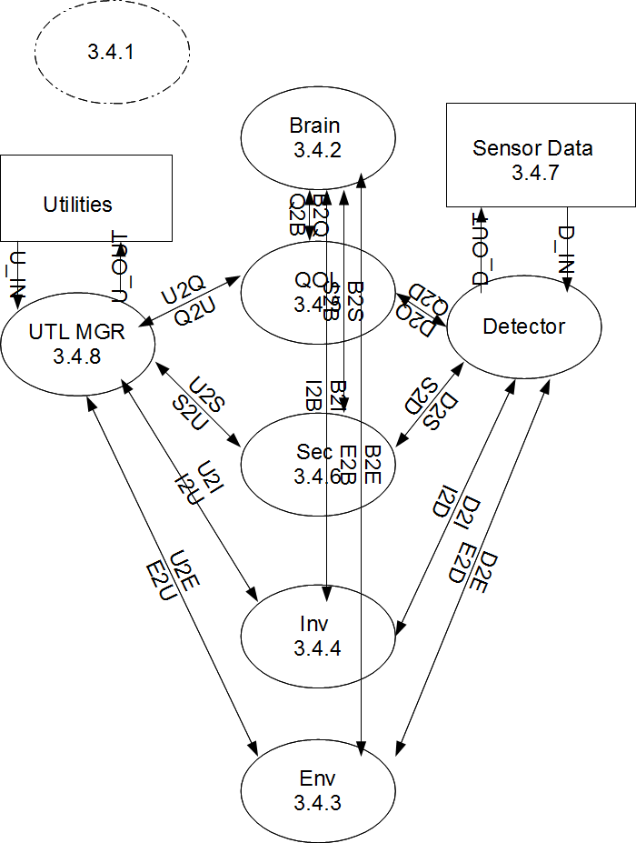
Figure 1: DFD-O

System State Diagram

Brain

Environmental

Inventory

Quality of Life

This process is the one for the Quality of Life segment for the system.

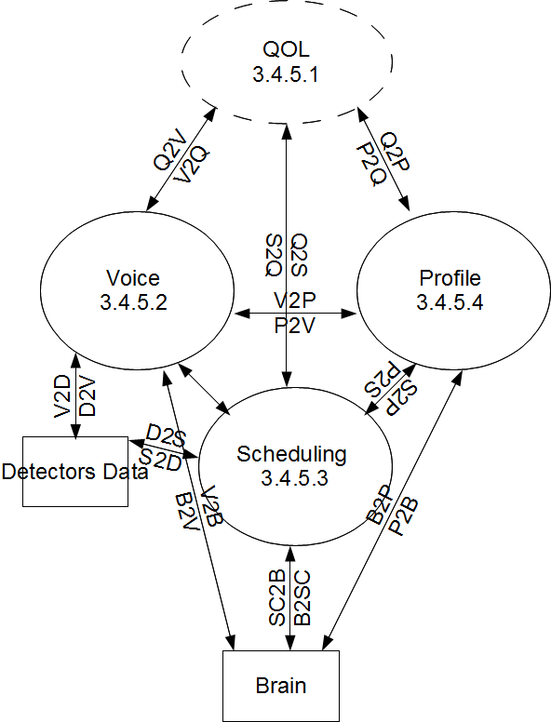

Figure 2: DFD-3.4.5

STD for qol

Voice
This part of the system describes how voice of authorized users is processed.
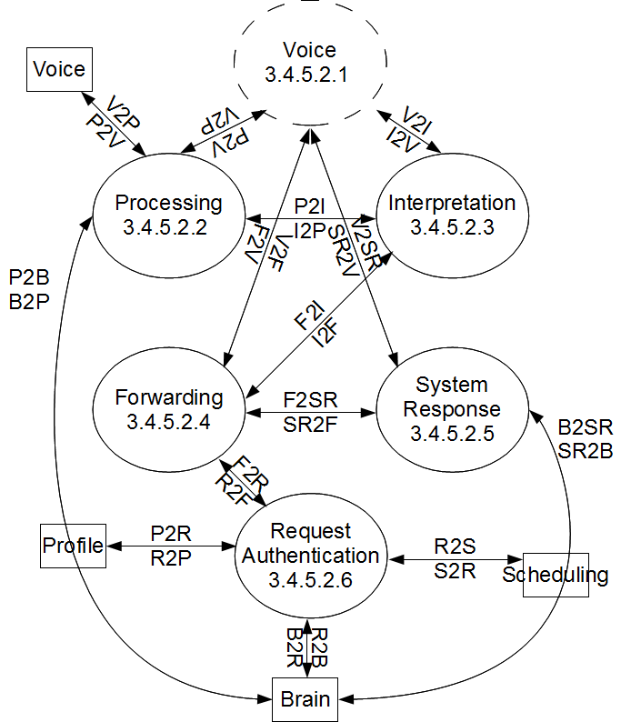
Figure 3: DFD-3.4.5.2

STD for Voice
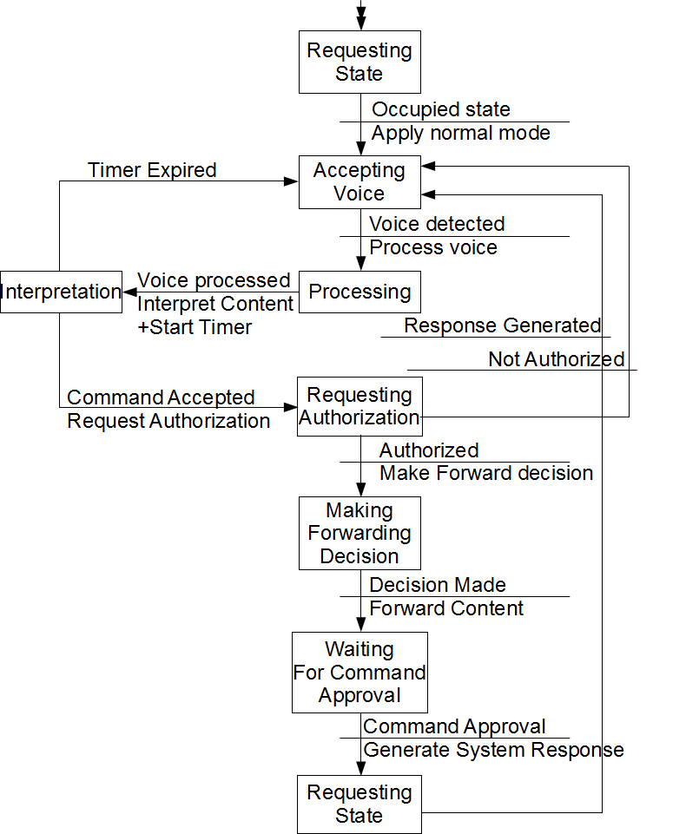
Figure 4: STD-3.4.5.2.1

Processing
This part of the system describes how voice processing is implemented.
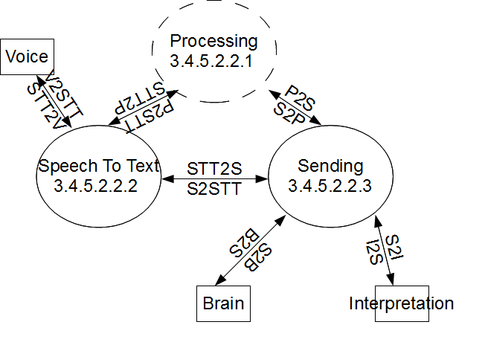
Figure 5: DFD-3.4.5.2.2

STD for Processing
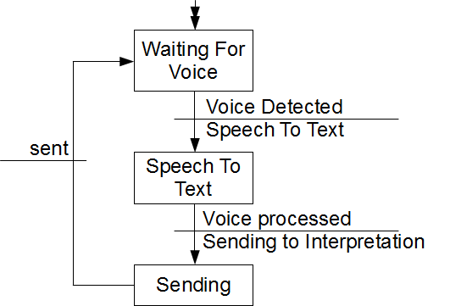
Figure 6: STD-3.4.5.2.2.1

Speech to Text
This part of the system translates speech into text.

Sending
This part of the system sends the translated text to interpretation.

Interpretation
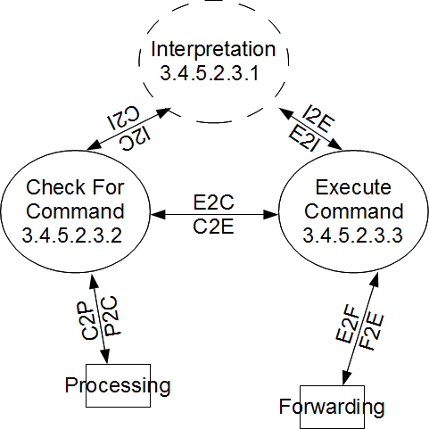
This part of the system interprets the translated command and it's attached user content.
Figure 7: DFD-3.4.5.2.3

STD for Interpretation
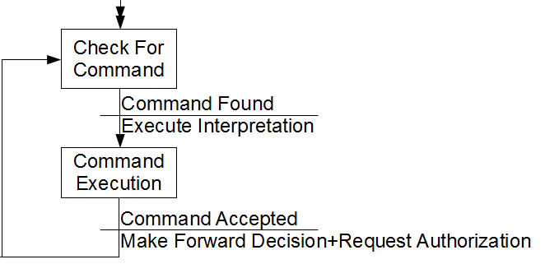
Figure 8: STD-3.4.5.2.3.1

Check for Command
This part of the system checks for commands within the processed text.

Execute Command
This part of the system executes the interpretation of the detected command.

Forwarding
This part of the system either forwards the command and content based on the command type or applies the respective mode based on the command type.
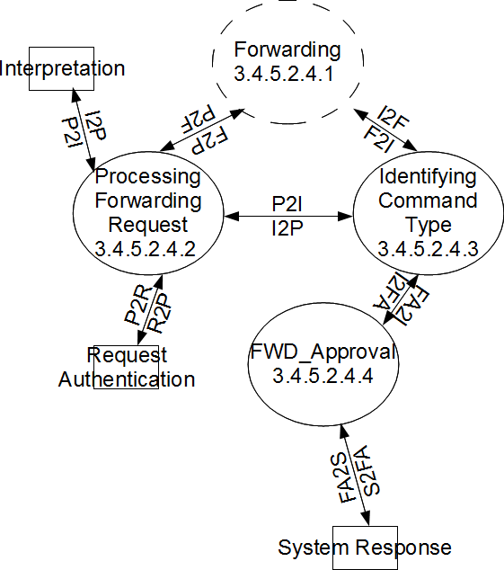
Figure 9: DFD-3.4.5.2.4

STD for Forwarding

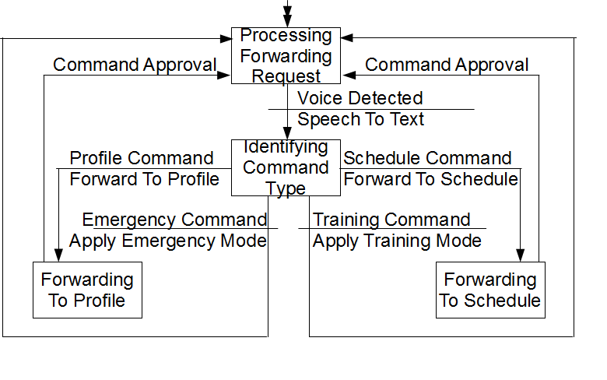
Figure 10: STD-3.4.5.2.4.1

Processing Forwarding Request
This part of the system detects the incoming voice requests.

Identifying Command Type
This part of the system identifies the command type based on a given list associating the two components (profile and schedule) with respective commands.

FWD-Approval
This part of the system states that the command and respective content have been forwarded successfully or not.

System Response
This part of the system generates a system response based on the applied command and respective content.
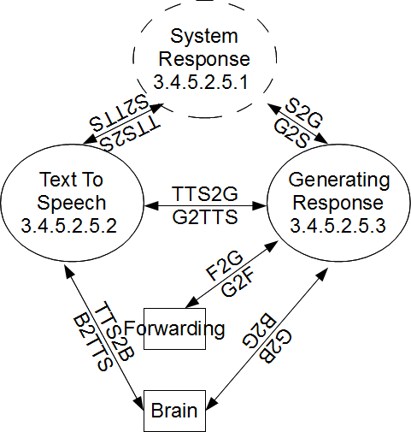
Figure 11: STD-3.4.5.2.5

STD for Response
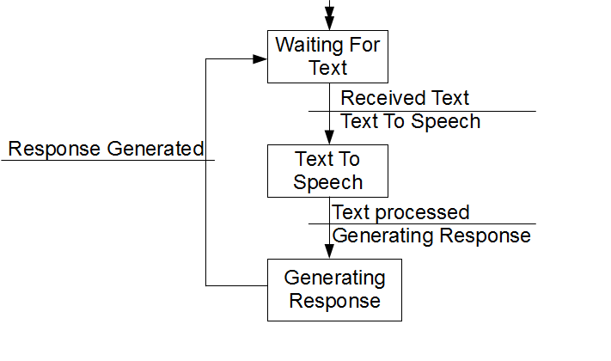
Figure 12: STD-3.4.5.2.5.1

Text to Speech
This part of the system translates the system text into speech.

Generating Response
This part of the system generates the spoken response for the user.

Scheduling
This is the process for the scheduling segment for the quality of life
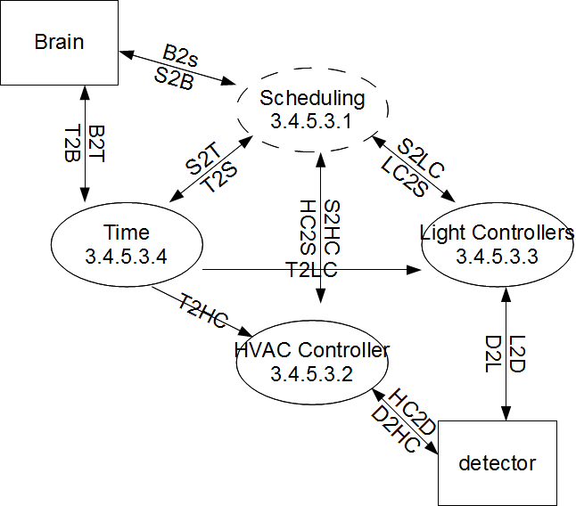

Figure 13: DFD-3.4.5.3

STD for Scheduling

HVAC
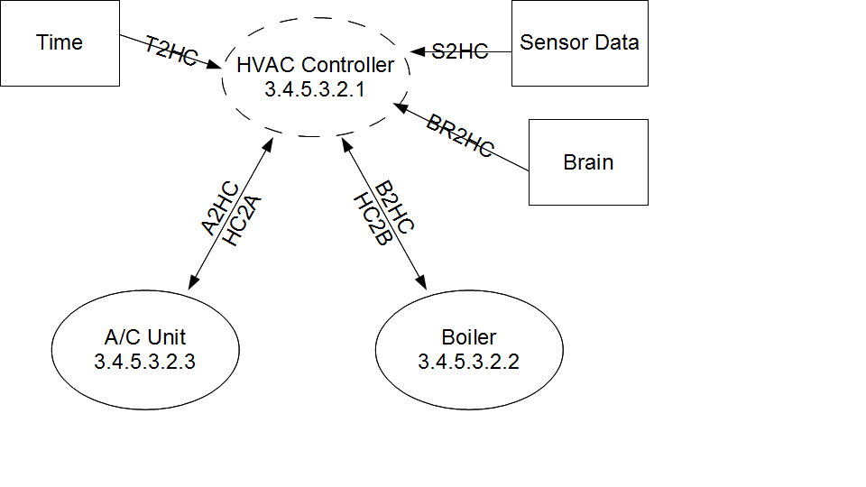
Figure 14: DFD-3.4.5.3.2

STD for HVAC
This is the state diagram for the HVAC controller. It starts off in a state waiting for the signal to turn the a/c or heat on or off.
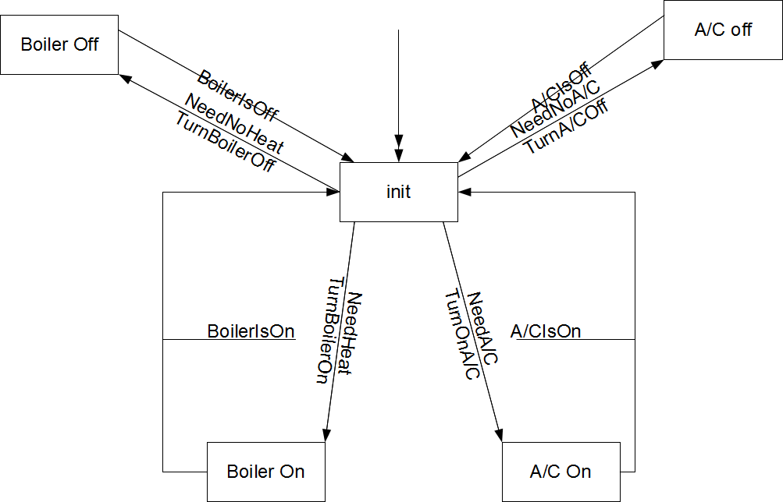
Figure 15: STD-3.4.5.3.2.1

Boiler
This process is when the boiler will wait for a command from the HVAC controller to turn on or off.

AC Unit
This process is when A/C will wait for a command from the HVAC controller to turn on or off.

Light Controller
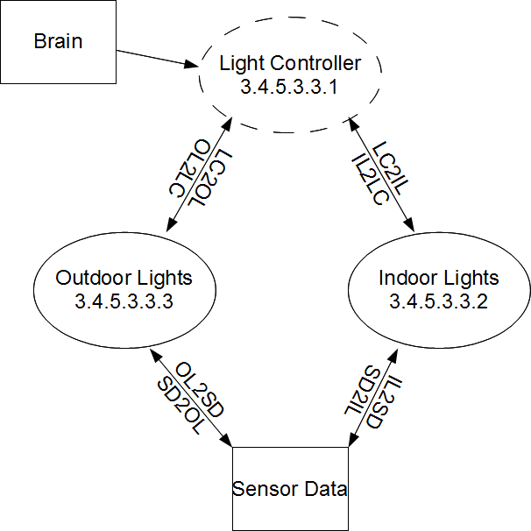
Figure 16: DFD-3.4.5.3.3

STD for light controller
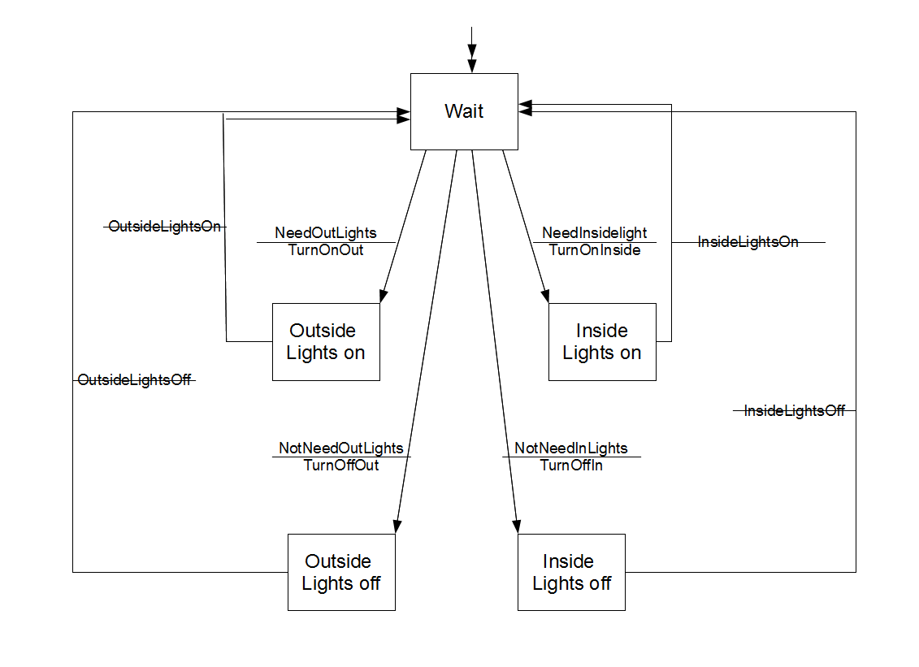
Figure 17: STD-3.4.5.3.3.1

Inside Lights
This process is to turn the inside lights on or off

Outside Lights
This process is to turn the outside lights on or off

Time

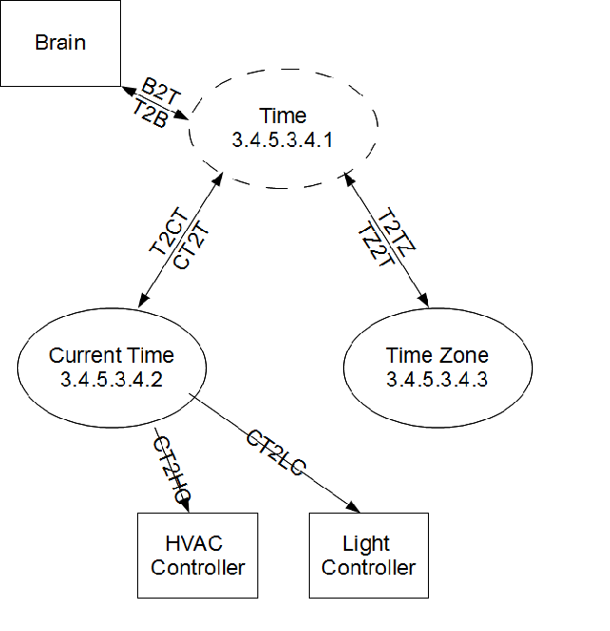

Figure 18: DFD-3.4.5.3.4

STD For Time
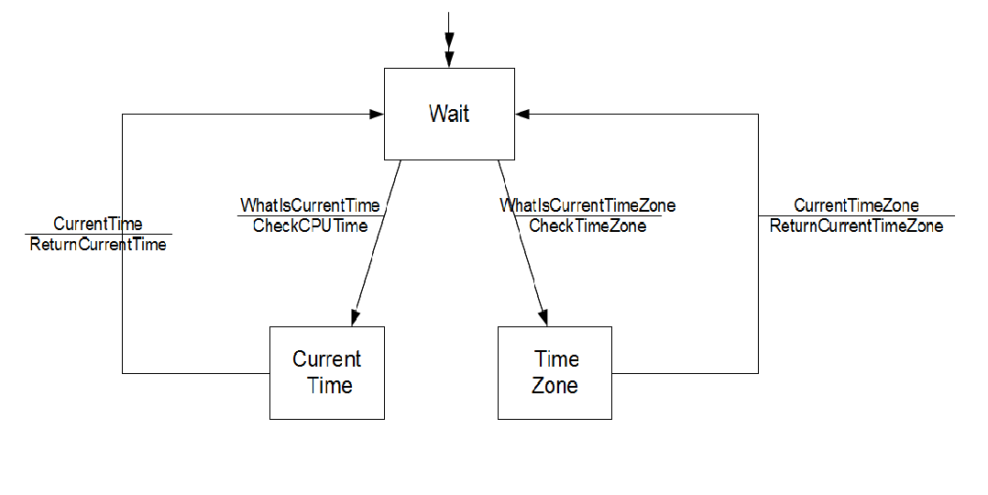
Figure 19: STD-3.4.5.3.4.1

Current Time
This is the current system time that will be reported back to the brain and controllers

Time Zone
This is the current system time zone that will report back to the brain to determine the sunrise and the sunset.

Profile

Profile DFD
This is the data flow diagram for the profile
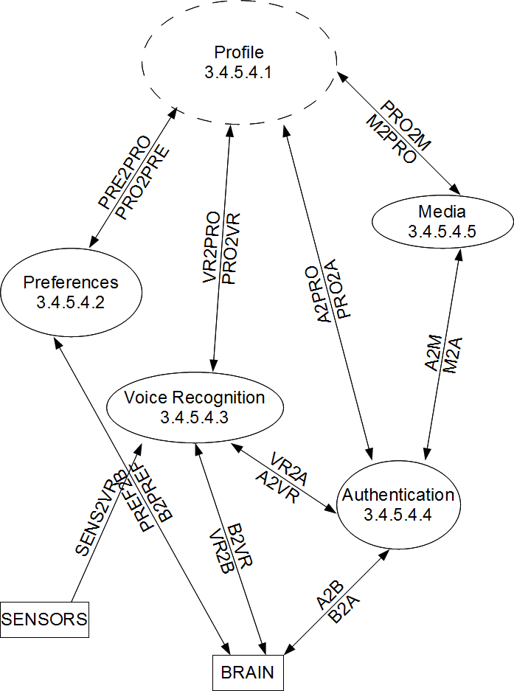
Figure 20: DFD-3.4.5.4.1

Preferences
The preferences maintains data on the users of the Smart House System.

Preferences DFD
This is the data flow diagram for the preferences.
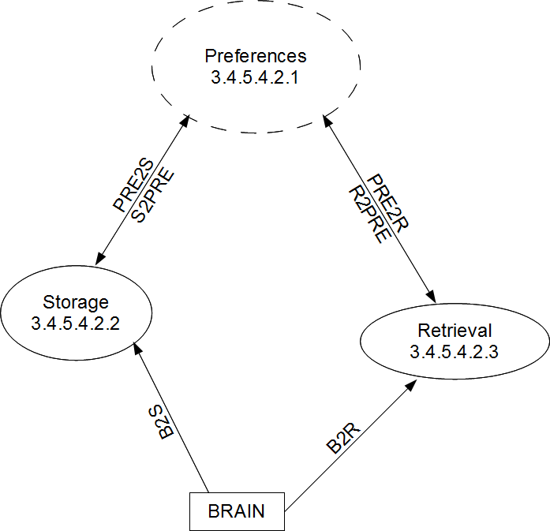
Figure 21: DFD-3.4.5.4.2.1

Storage
Storage is responsible for all storing operations on the profile data
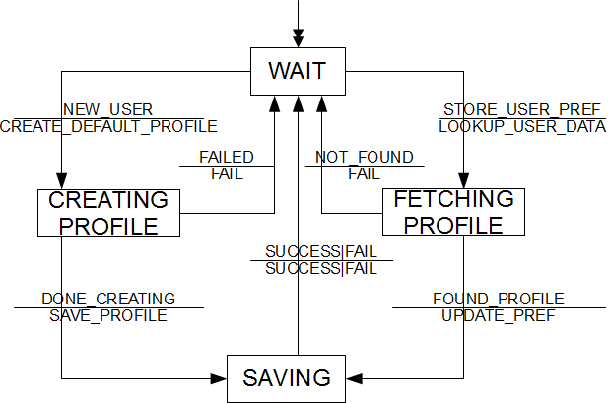
Figure 22: STD-3.4.5.4.2.2

Retrieval
Retrieval is responsible for high level requests of profile information.
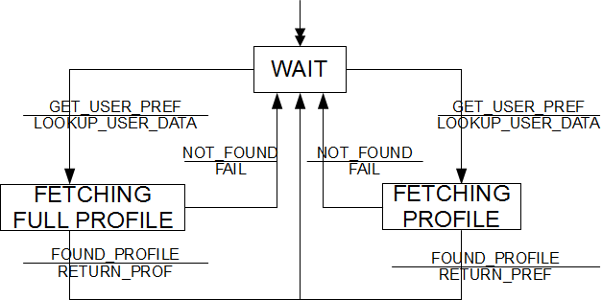
Figure 23: STD-3.4.5.4.2.3

Voice Recognition
Voice recognition combs through incoming audio data to identify who is speaking.
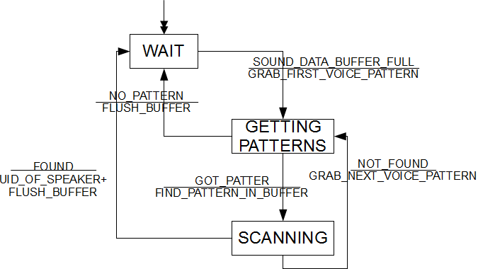
Figure 24: STD-3.4.5.4.3

Authentication
Authentication determines if a user is authorized to perform an action.
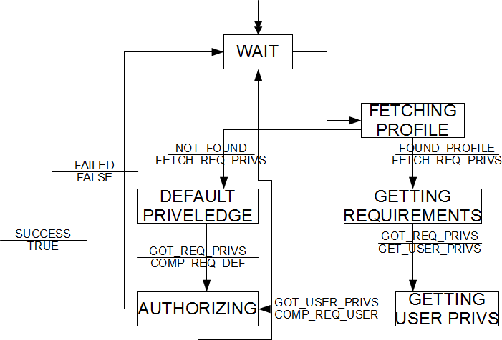
Figure 25: STD-3.4.5.4.4

Media
Media is responsible for outputting entertainment/atmospheric audio/video/picture data.

Media DFD
This is the Data Flow Diagram for Media
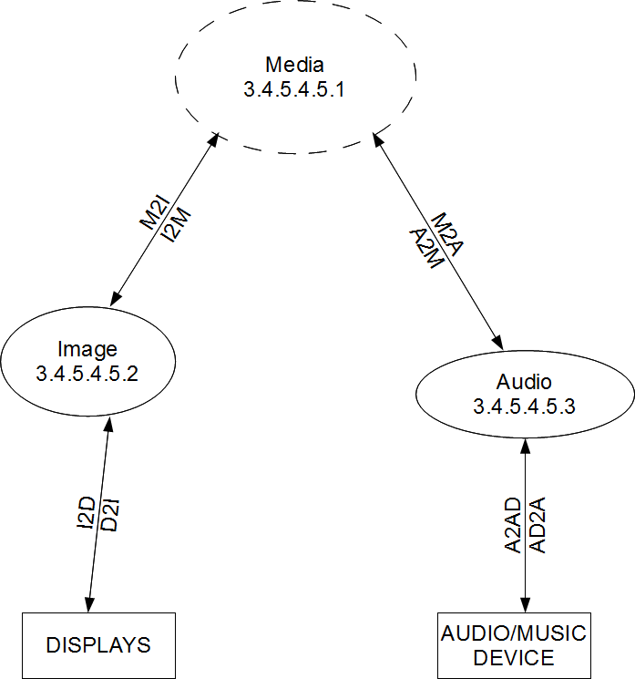
Figure 26: DFD-3.4.5.4.5

Image
Image is responsible for transferring users preferred visual data (paintings, photographs, etc) to external displays.

Audio
Audio is responsible for transferring users preferred audio data (audio books, songs, recordings, etc) to external audio devices for listening.

Security

Detector Data

Utility Manager

System internal data requirements

See Attached C:\Users\Andrew\Documents\Uri\Dropbox\Fall 2011\CSC 305\CSC305 Group\paper3\datadic.ods

datadic.ods

Adaptation requirements

Requirement 3.6.1 : Day Light Savings Time
Synopsis: | The system shall provide the correct time of day for the scheduling
Specifics: | A. The system should work off of the correct time zone that it is
Acceptance: | This requirement shall be verified by inspection.
Status: | Active
Notes: | This is used to turn the lights on or off.
Source: | Andrew Poirier

Requirement 3.6.2 : Light Controllers
Synopsis: | The system shall provide electronic light controllers to turn the lights on or off.
Specifics: | A. The system shall have electronic light controllers to control the electricity to the lighting devices when requested by the system.
Acceptance: | This requirement shall be verified by inspection.
Status: | Active
Notes: | This is used to turn the lights on or off.
Source: | Andrew Poirier

Requirement 3.6.3 : Age Groups
Synopsis: | The system shall provide adaptation for different aged users
Specifics: | - The System will have a group for adults  - The system will have a group for children.
Acceptance: | This requirement shall be verified by inspection.
Status: | Active
Notes: | This is used to change the interfaces and spelling level of the users in the house
Source: | Andrew Poirier

Requirement 3.6.4 : Background noise
Synopsis: | The system shall be able to filter out background noises from users’ commands.
Specifics: | - The system shall be able to distinguish between background noises and user commands through filtering.  - The system training shall be feasible from 0-130dB of background noise.  - The system interactions shall be feasible from 0-130 dB
Acceptance: | This requirement shall be verified by testing.
Status: | Active
Notes: | N/A
Source: | Andre Zierfuss

Safety requirements

Requirement 3.7.1 : Password Encryption
Synopsis: | The system shall be secured with password authentication
Specifics: | - All of the system data will be password protected to provide security of all commands and databases.
Acceptance: | This requirement shall be verified by inspection.
Status: | Active
Notes: | N/A
Source | Andrew Poirier

Requirement 3.7.2 : UL
Synopsis: | The system shall comply with all UL requirements.
Specifics: | - The system will comply with all UL requirements so the users do not get electrocuted by our devices
Acceptance: | This requirement shall be verified by inspection.
Status: | Active
Notes: | N/A
Source | Andrew Poirier

Requirement 3.7.3 : Emergency requests
Synopsis: | The system shall provide priorities for emergency relevant requests.
Specifics: | A. The system shall provide priorities to emergency requests while in emergency mode.  B. The system shall switch to emergency mode on received emergency requests initiated by keywords defined by the user.
Acceptance: | This requirement shall be verified by inspection.
Status: | Active
Notes: | N/A
Source | Andre Zierfuss

System environment requirement
Requirement 3.8.1 : Intruder detection
Synopsis: | The system shall differentiate between occupied and unoccupied to detect intruders.
Specifics: | - The system shall not provide guidance within the unoccupied-state  - The system shall apply the unoccupied-state to users with an unauthorized profile
Acceptance: | This requirement shall be verified by inspection.
Status: | Active
Notes: | N/A
Source: | Andre Zierfuss

Requirement 3.8.2 : Environment Temperature
Synopsis: | The System shall work under normal conditions through out different countries
Specifics: | A. The system will work in zones like Antarctica with really cold temperatures  B. The system will work in zones like Texas with really hot temperatures.
Acceptance: | This requirement shall be verified by inspection.
Status: | Active
Notes: | N/A
Source: | Andrew Poirier

Computer resource requirements

Software Environment
Requirement 3.9.1.1 : Software environment
Synopsis: | The system shall operate on standard operating systems designed for multi processing.
Specifics: | - The system shall operate on standard operating systems designed for multi processing.
Acceptance: | This requirement shall be verified by inspection.
Status: | Active
Notes: | N/A
Source: | Andre Zierfuss

Hardware Environment

Requirement 3.9.2.1 : Hardware environment
Synopsis: | The system shall operate on a parallel processing unit for an optimum support of parallel processing.
Specifics: | - The system shall operate on a parallel processing unit for an optimum support of parallel processing.
Acceptance: | This requirement shall be verified by inspection.
Status: | Active
Notes: | N/A
Source: | Andre Zierfuss

Natural Environment

Requirement 3.9.3 : Natural environment
Synopsis: | The system shall operate under every possible weather condition.
Specifics: | - The system shall operate on a multi-core processing unit for an optimum support of parallel processing.
Acceptance: | This requirement shall be verified by inspection.
Status: | Active
Notes: | N/A
Source: | Andre Zierfuss

Computer software requirements

Requirement 3.9.4 : Induced environment
Synopsis: | The system shall operate under every electromagnetic influence.
Specifics: | - The system shall operate under the influence of noise and electromagnetic radiations.
Acceptance: | This requirement shall be verified by inspection.
Status: | Active
Notes: | N/A
Source: | Andre Zierfuss

System quality factors

Requirement 3.10.1 : Voice processing units
Synopsis: | The system shall provide voice processing units for every available room.
Specifics: | - The system shall provide voice processing units for every available room.
Acceptance: | This requirement shall be verified by inspection.
Status: | Active
Notes: | N/A
Source: | Andre Zierfuss

Requirement 3.10.2 : Voice interpretation units
Synopsis: | The system shall provide command interpreting units for every voice processing unit.
Specifics: | - The system shall provide command interpreting units for every voice processing unit.
Acceptance: | This requirement shall be verified by inspection.
Status: | Active
Notes: | N/A
Source: | Andre Zierfuss

Computer Hardware Requirements
Requirement 3.10.1.1.1 : Storage Requirements

Synopsis: | The system shall include no less than 100 GB to store profile settings and other associated data, and the data shall be quickly accessible.
Specifics: | - The system shall use SSD(s) with SATA 6.0Gb/s for main storage and access of the profile settings and other associated data.  - The system shall have two backup SSDs that will each store a backup copy of the data on the main SSD.
Acceptance: | This requirement shall be verified by inspection.
Status: | Active
Notes: | N/A
Source: | Tyler Kopf

Requirement 3.10.1.1.2 : Memory Requirements
Synopsis: | The system shall include no less than 16 GB of DDR3 1600MHz RAM.
Specifics: | - The system shall use quad-channel ram of 4x4GB sticks minimum.
Acceptance: | This requirement shall be verified by inspection.
Status: | Active
Notes: | N/A
Source: | Tyler Kopf

Computer Hardware Resources Utilization
Requirement 3.10.2.1 : Internal memory
Synopsis: | The system shall provide sufficient internal memory for frequent voice processing.
Specifics: | - The system shall provide sufficient internal memory for frequent voice processing.
Acceptance: | This requirement shall be verified by inspection.
Status: | Active
Notes: | N/A
Source: | Andre Zierfuss

Computer communications requirements
Requirement 3.10.3.1 : Training software
Synopsis: | The system shall provide training software capturing the user’s voice characteristics for an optimized communication.
Specifics: | - The system shall provide training software capturing the user’s voice characteristics for an optimized communication.  - Launching the training software enables the training mode.
Acceptance: | This requirement shall be verified by inspection.
Status: | Active
Notes: | N/A
Source: | Andre Zierfuss

Requirement 3.10.3.2 : Voice data rates
Synopsis: | The system shall provide sufficient data rate that allows for an optimal communication flow.
Specifics: | - The system shall provide sufficient data rate that allows for an optimal communication flow.
Acceptance: | This requirement shall be verified by inspection.
Status: | Active
Notes: | N/A
Source: | Andre Zierfuss

System Quality Factors
Requirement 3.11.1 : Re-usability
Synopsis: | The system shall provide sufficient processing unit that can instantly distinguish different language characteristics.
Specifics: | - The system shall provide a sufficient processing unit that can instantly distinguish different language characteristics.
Acceptance: | This requirement shall be verified by inspection.
Status: | Active
Notes: | N/A
Source: | Andre Zierfuss

Design and Construction Constraints

Requirement 3.12.1 : Material constraints
Synopsis: | The system shall only cause electromagnetic radiations that are not harmful for people's health.
Specifics: | - The system shall only cause electromagnetic radiations that are not harmful for people's health.  - The system shall not cause any electromagnetic radiation hazards.
Acceptance: | This requirement shall be verified by inspection.
Status: | Active
Notes: | Electromagnetic radiation hazards according to the definitions a)-c) from the Federal Standard 1037C
Source: | Andre Zierfuss

Requirement 3.12.2 : Profile/Settings Storage
Synopsis: | The system shall store the data for the profile and settings using SQL.
Specifics: | - The system shall use SQL for all data basing needs.
Acceptance: | This requirement shall be verified by inspection.
Status: | Active
Notes: | N/A
Source: | Tyler Kopf
Requirement 3.12.3 : Programming Language
Synopsis: | The system shall be programmed in C++.
Specifics: | - The system shall be programmed in C++.  - Additional script files may be used, but the core of the running system shall be written in C++.  - Additional script files, if they are to be a standard scripting language, shall be written in Python.
Acceptance: | This requirement shall be verified by inspection.
Status: | Active
Notes: | N/A
Source: | Tyler Kopf

Personal-Related Requirements

Requirement 3.13.1 : Online support chat
Synopsis: | The system shall provide an online support chat in case user needs immediate guidance.
Specifics: | - The system shall provide an online support chat in case user needs immediate guidance.
Acceptance: | This requirement shall be verified by inspection.
Status: | Active
Notes: | N/A
Source: | Andre Zierfuss

Requirement 3.13.2 : Manual Specification

Synopsis: | The system shall include a manual written for the user.
Specifics: | - The manual shall be written in the languages of English, French, German, and Spanish.  - The manual shall include documentation on every system capability and system interface.  - The manual shall be written in such a manner that no special knowledge of the system is necessary to understand it.
Acceptance: | This requirement shall be verified by inspection.
Status: | Active
Notes: | N/A
Source: | Tyler Kopf

Training-Related Requirements

Requirement 3.14.1 : Training
Synopsis: | The system shall require no more than 10 minutes of training to use.
Specifics: | - The system shall require no more than 10 minutes of training to use.  - The system shall require less than 10 minutes to be trained to the user's voice.
Acceptance: | This requirement shall be verified by special qualification methods.
Status: | Active
Notes: | N/A
Source: | Andre Zierfuss

Logistics-related Requirements

Requirement 3.15.1 : Software Updates

Synopsis: | The software shall be updated through a CD update
Specifics: | - The software for this system will be updated from a CD that is mailed.  - The CD shall fit in a standard sized envelope.
Acceptance: | This requirement shall be verified by inspection.
Status: | Active
Notes: | N/A
Source: | Andrew Poirier

Requirement 3.15.2: Microphone maintenance
Synopsis: | The system requires maintenance work in case the performance of a microphone deteriorates over time.
Specifics: | - If the performance of a microphone deteriorates over time, it will be necessary to have the diaphragm cleaned.
Acceptance: | This requirement shall be verified by special qualification methods.
Status: | Active
Notes: | The user will need to talk to the supplier or manufacturer for details.
Source: | Andre Zierfuss

Other requirements

Requirement 3.16.1 : Digital user manual
Synopsis: | The system shall provide a digital user manual.
Specifics: | - The system shall provide a digital user manual.
Acceptance: | This requirement shall be verified by inspection.
Status: | Active
Notes: | N/A
Source: | Andre Zierfuss

Packaging Requirements

Requirement 3.17.1 : Voice command package
Synopsis: | The system’s voice processing package comprises of two main components, the voice processing unit and a respective voice interpreting unit.
Specifics: | - The system’s voice processing package comprises of two main components, the voice processing unit and a respective voice interpreting unit.
Acceptance: | This requirement shall be verified by inspection.
Status: | Active
Notes: | N/A
Source: | Andre Zierfuss

Requirement 3.17.2: Packaging Material
Synopsis: | The system shall be packaged in a water tight enevelope.
Specifics: | A. The system software will be packaged in a water tight enevlope to ensure no damage when being shipped
Acceptance: | This requirement shall be verified by special qualification methods.
Status: | Active
Notes: | Water = bad
Source: | Andrew Poirier

Precedence and Criticality of Requirements
The fulfillment of the requirements listed in this section is crucial for the functioning of the system.

Qualification Provisions

Requirements traceability

Notes

